Ideation Phase
Empathize & Discover

Date | 19-02-2026
Team ID | LTVIP2026TMIDS34682
Project Name | BOOK-NEST
Maximum Marks | 4 Marks

Empathy Map Canvas:
An empathy map is a simple and easy-to-understand visual representation that captures knowledge about the user’s behaviours, thoughts, feelings, and challenges. It helps teams better understand users and design effective solutions based on their needs.
BookNest application to provide a better user experience.
Creating this empathy map helped us understand the problems faced by students and users while searching, browsing, and booking books. This understanding helped in developing the Example:
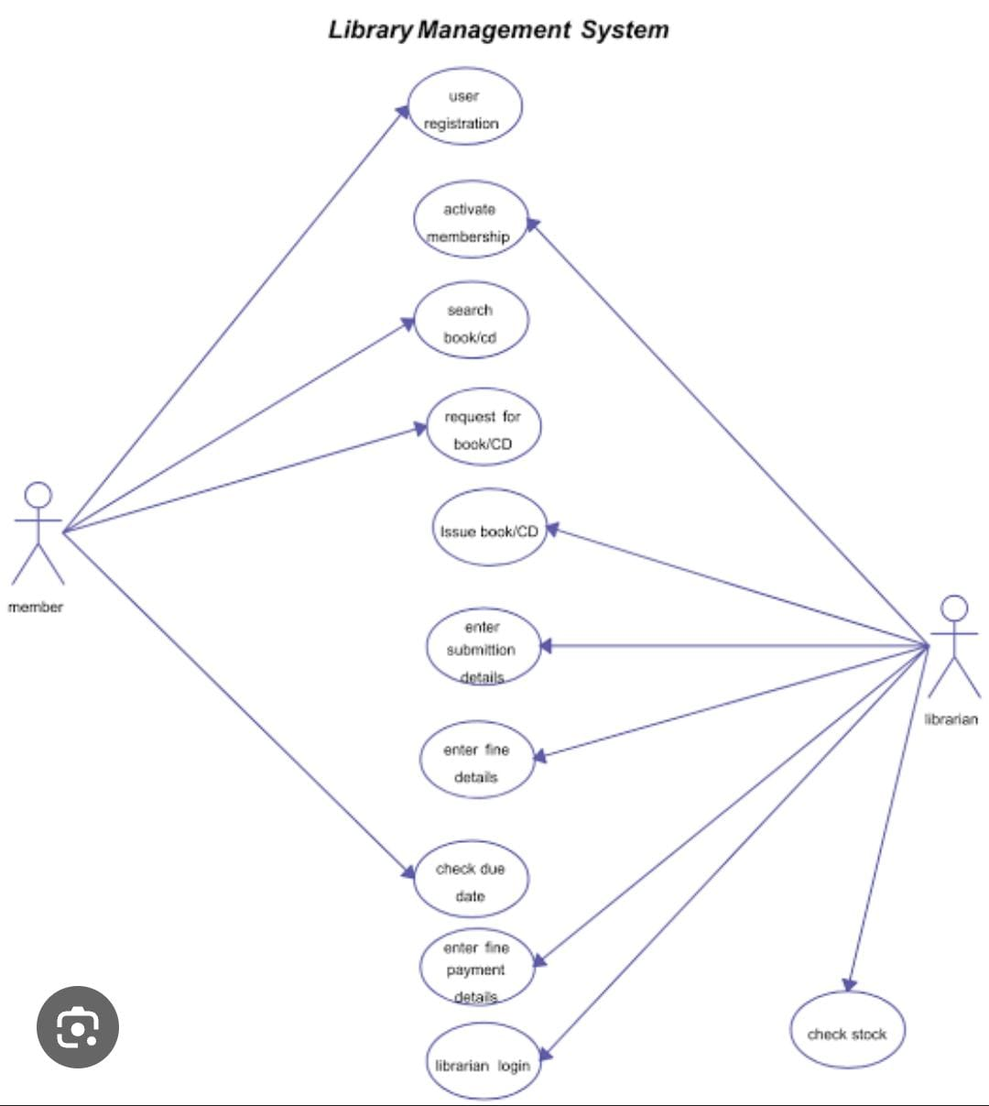

Reference: https://www.mural.co/templates/empathy-map-canvas

Example: Food Ordering & Delivery Application


